Animal Computer Interaction:

Enrichment Indicating Sea Otter Health

Nathaly Jose-Maria  
B.S. Computer Science  
Georgia Institute of Technology  
 [njosemaria3@gatech.edu](mailto:njosemaria3@gatech.edu)

Dhruv Tripathi   
B.S. Mechanical Engineering  
Georgia Institute of Technology  
 [dtripathi3@gatech.edu](mailto:dtripathi3@gatech.edu)

Adithya Ramanujam  
B.S. Computer Science  
Georgia Institute of Technology  
[aramanujam7@gatech.edu](mailto:aramanujam7@gatech.edu)

Jacqueline Le  
B.S. Computer Science  
Georgia Institute of Technology  
[jacqueline7@gatech.edu](mailto:jacqueline7@gatech.edu)

ABSTRACT

Aquariums play an important role in our world in a variety of ways: they aid in animal conservation, animal research, and animal rehabilitation, care, and rescue. They also provide education and entertainment for humans. Something that has become a concern for animals in captivity is that it is not always easy to determine the health of these animals. When thinking about who can benefit from using technology, animals are not typically the ones that come to mind.  However, by employing wearable technology and instrumented toys in the everyday lives of these animals, they can also reap benefits through measures such as health, behavior, and performance tracking. In completing this project, we sought to explore ways to capture health information on sea otters in captivity through their interactions with instrumented enrichment toys, which will in turn inform the aquarium handlers of the otters' health statuses. The Animal-Computer Interaction Lab here at Georgia Tech has already started an exploration into creating computer-driven enrichment toys for the sea otters at the Georgia Aquarium, and our team advanced this research by creating a prototype for a new instrumented enrichment toy that will resemble objects in the sea otters' natural habitat and will also allow them to display natural behaviors when interacting with the toy.

INTRODUCTION

After researching the play behaviors of sea otters in the wild and in captivity, we learned that otters interact with the toys and objects in their environment through behaviors such as biting, smashing, and chasing [3, 4].  Additionally, while examining past animal computer interaction studies with otters and dogs, we analyzed the methods in which sensors were integrated into the toys and other gear to record certain behaviors [1, 9 10].  Similar to Josh Terry's previous work with otters, we created a toy equipped with sensors that allow the otter to interact with it as they would with something in the wild. Our toy differs in various ways to Terry’s. First, our toy resembles sea kelp, an alga commonly found in the otter’s natural habitat. We sought to provide a more natural enrichment item to more closely resemble otter environments and therefore encourage play with an item familiar to the otters already. We hoped this would decreased levels of anxiety and discomfort to produce more reliable results during behavioral testing. Next, our toy requires more involvement from the aquarium handlers than Terry’s. This is to ensure the safety of the otters as there are computational components that could be exposed to water and/or come lose to potentially harm the animal. Having the handler assist play simply provides an extra precaution. Said computational components include two sensors that collect accelerometer and gyroscope data to give us insight to exactly how they play with the toy.

**KEYWORDS**

Sea Otters, Animal Computer Interaction, Ubiquitous Computing

1 Previous/Related Work

Most of the work completed in this project is guided by the research conducted in the Animal-Computer Interaction (ACI) Lab since the research aims to progress the emerging field of animal computer interaction through technological interfaces for inter-species communication [11]. The demands of designing devices for animals tend to be stricter, so related works up to this current point in time include wearable devices or devices with basic interactions [9, 10]. Based on the outcomes of this research, we see that devices can be built with the expectation that animals can learn to have a simple understanding of how to interact with technology even if they do not understand the purpose of the interactions [9]. Research has also been completed to explore larger timescale monitoring, including concluding whether dogs are suitable for service roles [10]; this work parallels to our work in analyzing large timescales of data to infer health information of animals in this project.

As a team, we focused our research on marine mammal enrichment and health informatics. Since not much research has been conducted thus far on recording marine mammal behavior with instrumented toys, the primary source to guide our project was Josh Terry's research on marine mammal health informatics [1]. In this research, Terry developed several otter toys that engaged their natural behaviors, tested each toy to see which would be the best choice, and further optimized the toy design with a more waterproof material that was also safe for the otters [1]. The final design was then integrated with a MicroSD card, IMUs, and other technology to record data on the otters' behaviors [1]. We were able to gain insight through this research on otter behaviors such as biting, smashing, spinning, and anxiety, that could be displayed when playing with the toy. We conducted further research to better understand the behaviors of otters both in the wild and in captivity.

Our work follows but also differs from Terry's work in a variety of ways. Like Terry, we developed an instrumented toy that recorded data when the otters interact with it and allowed for the otters to display natural behaviors. Our toy differs in that it is arguably more identical to kelp, an object found in the otters' natural habitat. This toy will also be created with an entirely different material and build, and it will have different technical integrations due to the toy not being waterproof. The primary goal of this project is the development of the toy and the analysis of the data recorded and does not include building an interface to present the data to the handlers.

We looked at various sources that demonstrated the behavior of otters in captivity. One source captured the presence of the smashing, biting, and spinning behaviors when playing with several toys [5], which were also exhibited in Terry's work. Other sources consisted of videos of otters provided by aquariums that highlighted unique behaviors when engaging with a variety of toys [2, 3, 4, 7]. Out of the four aquariums and zoos that we studied, they had food motivated toys [2, 3, 4], and one uniquely had ice as a toy for their otters [7]. The otters demonstrated biting, grabbing, and bashing behaviors on all toys they encountered. After analyzing these sources, the team came to the conclusion that otters are very rough players and will require durable enrichment toys that can withstand the intensity of their play sessions.

We decided to develop a toy with a kelp-like design with inspiration from these sources, similar to the one shown in the video from the Oregon Zoo [2]. The kelp design was determined to be the best choice as it allowed the handlers to have larger involvement in the enrichment session and to also closely monitor the presence of technology in their aquatic environments. Furthermore, more quantifiable data from the interactions can be collected through noting the position changes by both the otter and the handler and the involvement of any spinning or twisting movements.

2 Our Work

**2.1 Methodology**

Development of the tug toy was motivated to represent natural sea kelp. Thus, the first and only iteration of the toy stood at 5’ by 7.5” with a thick, brown, canvas base (Figure 1). Canvas was utilized given its puncture-resistant properties. Moreover, the toy contains two pockets, each 5.5” by 7.5” at 8.5” from each end of the toy, to enclose the IMUs that will measure handler and otter interaction (Figure 2). The spacing was intended to provide both subjects with ample handling space.

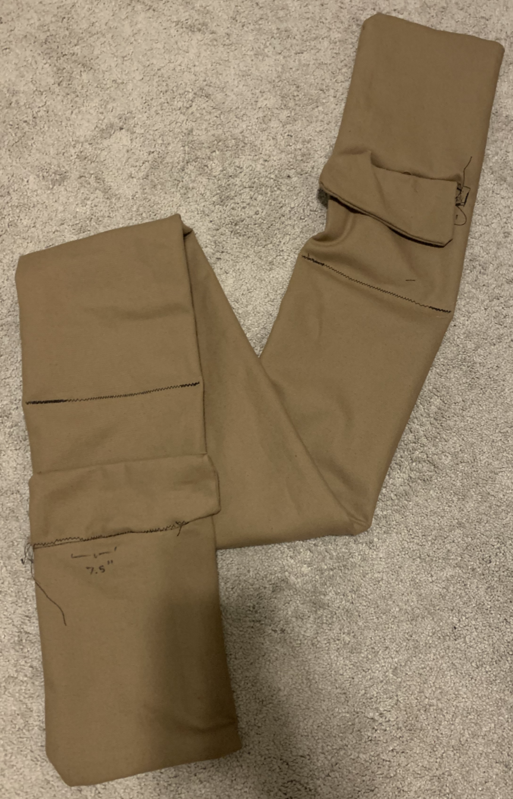

**Figure 1: Newly Made Sea Kelp Toy - General View.** This image demonstrated the final product of the first and only round of toy production. The toy is folded in this picture as it reached the 5’ of canvas that was blank and highly redundant toward the middle section between the two pockets and therefore not worth expanding for the image.

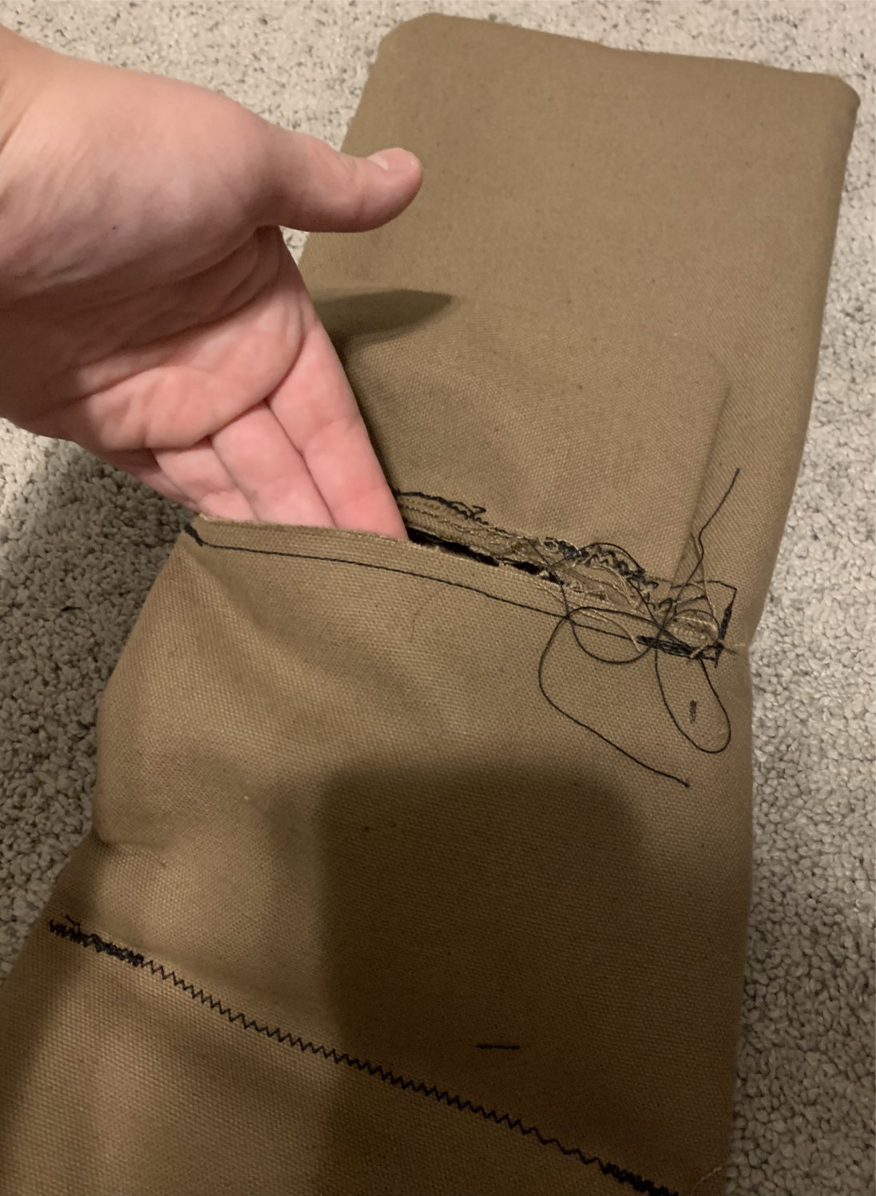

**Figure 2: Newly Made Sea Kelp Toy – Pocket View.** This image demonstrates how the pockets on each end of the toy opened up. It features an incision in the front layer of the toy with a flap of extra material stitched above said incision. There is stitching 5.5" below the incision across both the front and back layers to secure the IMUs from falling through the hollow middle of the toy.

The IMUs housed in the kelp toy were built with ESP32 MCU which had Wi-Fi and Bluetooth capabilities with an MPU6050 (Figures 7-8) which provided three axis accelerometer and gyroscope measurements. After the system was constructed, we were able to load a simple program that relayed measurements in real-time over a web server. Electronics were placed within a 3-D printed enclosure each 3.5” by 3” by .5” (Figure 8) before being screwed into place for protection from thrashing and biting and then information was collected. A battery was also placed within the enclosures to provide voltage to all electronics. Two such systems were created for the toy – one to be inserted into the handler and one into the otter end.

Since we were unable to arrange a session to test the toy with otters at the aquarium, we tested the toy with a highly trained dog with our project advisor as the handler. We felt confident in pursuing this alternative route for behavioral testing as canine play behaviors closely resemble that of otters, including biting, thrashing, and pulling. Thus, to ensure our initial prototype design was worth maintaining in actual otter testing, we thought to eliminate initial design issues with a quick and easy canine interaction. Despite not experimenting with otters, we believed the results would be highly indicative of otter experimentation given the animals’ similar behaviors. The purpose of experimentation was to mostly ensure our technology was working correctly and that our design was valid. We believed using this easier interaction would better inform us on our sensor results and data identification in a way that would prepare us for legitimate otter interaction without as much confusion.

Before starting the actual experimentation, we had the dog play with the toy without having the sensors inside to familiarize the dog with the toy and to observe any preferred bite locations and any other behaviors like thrashing (Figures 3-4). After the dog learned that the object was a playable toy, we placed the sensors that measure acceleration and gyroscopic data in the pockets of the toy and conducted five one-minute trials with the handler holding one side of the toy and the dog tugging on the other end (Figures 5-6).

Further experimentation was performed with a hand held model mimicking the dogs movement. This was due to the availability of the handler for the trained dog not matching with the teams schedule. The hand held experimentation worked to provide data over longer time frames to get more comprehensive and accurate understanding and metrics on the device and data processing models.

After the experiment, we performed data analysis on the collected data. The first pre-processing we conducted was applying a low pass filter to the data – we started with a low-pass moving average filter but gravitated towards a Kalman filter due to its prior application in this field. The data from there that we captured included the average jerk force, asymmetry in play behavior (utilizing the gyroscopic measurements), playtime, and finally using the Kalman filter [12] we could present an overview of the interaction over time in terms of pitch and roll.

This session taught us a lot about hardware and data analysis. We ran into a couple of issues with data collection over Wi-Fi, so we reconfigured that protocol, and based off the canine data built more robust data analysis pipelines. To culminate our prototyping, we performed one more supervised human test where a human user simulated the affordances that we expected an otter to perform. The added benefit of this form of testing is we classify certain actions (Figure 10). The human testing allowed us to analyze improvements to the prototype design which involved a snugger fit for the ESP32 and MPU6050 and recognitions in the Wi-Fi protocol that improved efficiency and maintained a more constant sampling rate. Additionally, the data analysis we performed on this training data I.e., position over time with a Kalman filter could be more easily validated against the ground truth.

2.2 Results

All five noted trials exhibited regripping, thrashing, and pulling behaviors. The second trial and onward elicited a kill behavior by the dog on more than one occasion. The third trial showed the dog having an issue with situating a good, powerful bite, which we later learned was the animal oriented IMU falling through its stitching into the biting end of the toy (Figure 5). This instance left both the dog and IMU undamaged because of the dog’s wit and the IMU’s 3D-printed encasing. At the end of all trials, there were several bite marks imprinted on the material, but there was only a single, small puncture of significance (Figure 5). The method of wireless data transfer worked albeit minor permutations in the sampling rate. However, this component needs to be further examined for aqueous and longer timeframe trials.

After running the collected data through the data analysis pipeline the results created were intuitive. First, the sensor measurements didn’t report much activity on the z-dimension which was to be expected. Furthermore, the pattern of pitch and roll oscillated which could be validated with the canine experimentation where we observed a swaying pattern of play. Finally, the average jerk force exerted waned with time which was also expected. The results proved significant in the context of modelling world behavior but additionally the methodology of data analysis proved abstract and robust enough to translate to sea otter interaction.

We can now take the opportunity to look at the theoretical data analysis pipeline that derives our results. First, starting with two streams of input data – the handler and animal IMUs. To isolate the noise resulting from handler movement a simple corrective protocol was done.

$${\overline{A}}_{calc} = {\overline{A}}_{animal} - {\overline{A}}_{handler}$$

Where A represents the vectorized accelerometer measurements (x, y, and z axes). This process was then repeated for the gyroscope data. Afterwards with this data there were some results that we could create from the raw data itself. Namely the average jerk strength. This was done with a simple derivative calculation. An additional level of consideration we gave to this process was isolating jerk events by only including measurements that were in the top N% of magnitude (where fluctuated dependent on the training set)

$$\frac{1}{n}⋅\sum_{i = 1}^{n}{\frac{A_{calc}\left(i\right)-A_{calc}\left(i-1\right)}{dt}}$$

Here dt is related to our sampling rate and n is related to the time of observation. For further results we utilized the Kalman filter. After processing the data through this low pass filter some further results, including measuring asymmetry. This was done by classifying jerk events by their directionality and measuring the cumulative direction of jerk events to measure asymmetry in the *x* and *y* direction (asymmetry in the zdirection is assumed given the setup)

The last result collected was the time on vs. Time off measurement where we measured the proportion of time that the toy was “in use” over the total training time. We again employed a measurement where we captured when the magnitude was in the Nth percentile (this N is lower than the jerk event N to capture a broader definition of interaction).

3 Discussion

Through the iterative development of our prototype and the subsequent testing we have learned about the potential and limitations of our proposed approach. First, the proposed sea kelp design and the canvas material not dissimilar to a dog toy that was used for our prototype proved to be ideal for interactivity and resilience. The toy provided enough affordances to capture a variety of behavioral patterns and the kelp design was novel but also intuitive for sea otters to utilize given its similarity to kelp in their environment. A main point of concern early in our development was the resilience of our design. Early discussions noted that sea otters often played forcefully and given the embedded technology and the aqueous environment it would be of utmost importance to create a robust toy. The canvas material used for the prototype held up well during dog testing resisting rigorous biting and tugging. Additionally, the material did well under rudimentary water testing conditions.

One learning outcome of this entire process was how to effectively capture interaction. The prototype design did a good job of capturing *most* interactions. However, one interaction observed in the canine testing phase was middle toy biting where the dog bit the toy in an area sufficiently far enough away from the sensors to not show up in the accelerometer or gyroscopic data. This led us to the question of whether otters would behave similarly? On one hand both otters and canines have the same type of biting behaviors, but on the other hand otters also use their hands as a method of toy interaction the difference in frequencies and magnitudes of behaviors like thrashing could be different from that of a dog. Another point of difference that could affect results is the introduction of water giving a large mobility in the z direction, this could potentially allow for a greater change in MPU positioning making it difficult the discern which direction the otter is moving from the data.

The results of our inquiry starting from research to prototyping demonstrate the practicality of creating sensing instrumentation for sea otters that resembles artifices of their natural environment. The sensing capabilities within the sea kelp design involve traditional gyroscope and accelerometer measurements, but the sea kelp model is novel. Furthermore, the data analysis involved is meant to prioritize providing high-level results that aquarium caregivers and other relevant stakeholders can easily analyze.

As a team we intended to create a robust prototype based on a sea kelp toy with sensing capabilities and we believe that we accomplished that. The only room gap between expectations and deliverables comes down to the data analysis portion. There are inferences that we can make about health data over larger timescales that haven’t been incorporated into the current data model. It was hard to incorporate this given the lack of available data, limited testing, and inability to coordinate testing with live sea otters.

4 Future Work

Given the limited time allotted to this project, there are many items of interest that could be looked at for further work. First, we can address the structural integrity of the toy further. This would involve fixing the stitching to avoid loose IMUs; we noticed during experimentation that the pocket which housed the IMU system was a little bit loose and added a degree of noise to the measurements independent of the animal interactions that are undesirable. Additional configurations of the physical toy involve adding a third IMU in the middle of the toy which could accommodate for different bite positions, altering the dimensionality of the toy to encourage a single bite point which would be easier to identify in data analysis, and holistically making the toy more naturalistic in both color and texture.

Aside from the physical prototype, future work could involve more rigorous experimentation. For the purposes of our design, we conducted canine testing which did a good job of modelling how this toy would be used for sea otters, but it doesn’t replace actual sea otter testing. In the future we would like the opportunity to test with real sea otters and capture the range of their behaviors under supervised testing. We could also take the opportunity at that point to test different bite locations more closely and ascertain if that impacts the output data significantly. Overall, more naturalistic and comprehensive testing would be a key focus of future work to make sure the physical design as well as the data analysis pipeline captures the full range of interaction.

Another point of improvement that would be helpful in shifting to otter experimentation deals with the acceleration and gyroscopic data collected being in the frame of reference to the MPU. The best option for data collection would be using a frame of reference or coordinate system based on the otters position and orientation such that data collected could be connected to the otters body. This would allow for potentially greater insight into sides or orientations that the otter prefers and allows for deductions on muscular health when data collected is off baseline.

Finally, the data analysis component of our design is an area that could be elaborated on with future work. As aforementioned in the discussion section it would be useful to capture long term trends in our data which would involve lengthy time studies and provide information such as reduced bite force over time, asymmetry in play indicating some physiological distress, etc. Another component of data analysis that should be incorporated into future work is more machine learning and intelligence. In the future, we intend to create a labeled set of data that classifies different play behaviors such as tugging, biting, swiping, and twirling to then classify how individual sea otters play with a specific toy.

5 Conclusions

From the experiments conducted, it can be seen that utilization of IMU’s are effective at gathering vigor of play for dogs which can be extrapolated out to animals such as otters. Furthermore, the data processing pipeline was able to discern different types of movements conducted such as the “kill behavior” and tugging canniness often exhibit. Another sign contributing to the accuracy of the information gathered is visible decrease in vigor from exhaustion being reflected withing the jerk motion values decreasing over time. These results are promising to be able to identify different types of movement that otters will exhibit as well. Though the processing seems to be closing into the desired progress, considerations for long term durability, safety, and waterproofing must be made before the device is ready for testing within an aquarium environment with otters.

REFERENCES

[1] Terry, J. (2022). Marine Mammal Health Informatics. Recent Work. Retrieved November 2, 2022 from <https://www.joshterry.tech/>.

[2] Oregon Zoo. [Oregon Zoo]. (2019, Jul. 30). Sea Otter Pup Tries New Toys [Video]. YouTube. <https://youtu.be/7NSBP3cIPZ4.>

[3] The Sacramento Zoo. [TheSacramentoZoo]. (2013, Dec. 19). River Otters Playing with New Toys [Video]. YouTube. <https://youtu.be/rlML22j_KOA.>

[4] Paradise Wildlife Park. [Paradise Wildlife Park]. (2020, Dec. 22). Otters Play With New Enrichment Toy! [Video]. YouTube. <https://youtu.be/8_z38pPQe_E.>

[5] Sowa, S. (2015). “Sea Otter Enrichment at the Shedd Aquarium.” Marine Mammal Internship Shedd Aquarium. Retrieved November 2, 2022 from <https://www.researchgate.net/profile/Stephanie-Sowa/publication/273724486_Sea_Otter_Enrichment/links/5509c03a0cf26198a639a866/Sea-Otter-Enrichment.pdf>.

[6] Bandini, E., Bandini, M., & Tennie, C. (2021). “A short report on the extent of stone handling behavior across otter species.” Animal Behavior and Cognition, 8(1), 15-22. <https://doi.org/10.26451/abc.08.01.02.2021>.

[7] Audubon Nature Institute. [Audubon Nature Institute]. (2011, Jan. 27). Sea Otters Love Ice! [Video]. YouTube. <https://youtu.be/k5gMPstOF64.>

[8] Foster-Turley, P. & Markowitz, H. (1982). “A captive behavioral enrichment study with Asian small-clawed river otters (Aonyz cinerea).” Zoo Biology, 1(1), p. 29-43. <https://doi.org/10.1002/zoo.1430010104>.

[9] Jackson, M., Zeagler, C., Valentin, G., Martin, A., Martin, V., Delawalla, A., Blount, W., Eir-   
ing, S., Hollis, R., Kshirsagar, Y., & Starner, T. (2013). Facilitating Interactions for Dogs with   
Occupations: Wearable Dog-Activated Interfaces. ISWC’13, New York City, United States, <https://smartech.gatech.edu/bitstream/handle/1853/52140/iswc198GV.pdf>.

[10] Byrne, C., Zuerndorfer, J., Freil, L., Han, X., Sirolly, A., Gilliland, S., Starner, T., & Jackson, M.   
(2017). “Predicting the Suitability of Service Animals Using Instrumented Dog Toys.” Proceedings of the ACM on Interactive, Mobile, Wearable and Ubiquitous Technologies, 1(4), 127, pp 1-20. <https://doi.org/10.1145/3161184>.

[11] Animal-Computer Interaction Lab. GVU Center. (2019, February 25). Retrieved December 3, 2022, from <https://gvu.gatech.edu/research/labs/animal-computer-interaction-lab>

[12] Welch, G., & Bishop, G. (1995). An introduction to the Kalman filter. <https://perso.crans.org/club-krobot/doc/kalman.pdf>.

APPENDIX

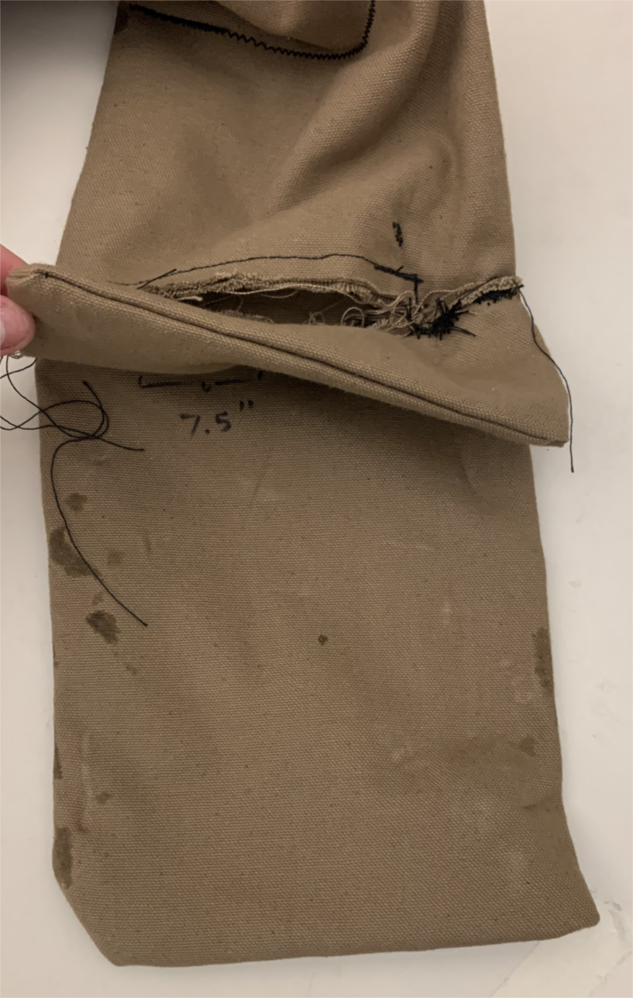

**Figure 3: Toy After Initial Play Session with No Monitoring – Front View.** This image shows some of the marks left by the dog. Of note are the bites aimed towards the sides of the toys and very close in distance to the start of the IMU pocket. This prompted the suggestion of moving the IMU more upward given preference to bite more inward on the toy than expected.

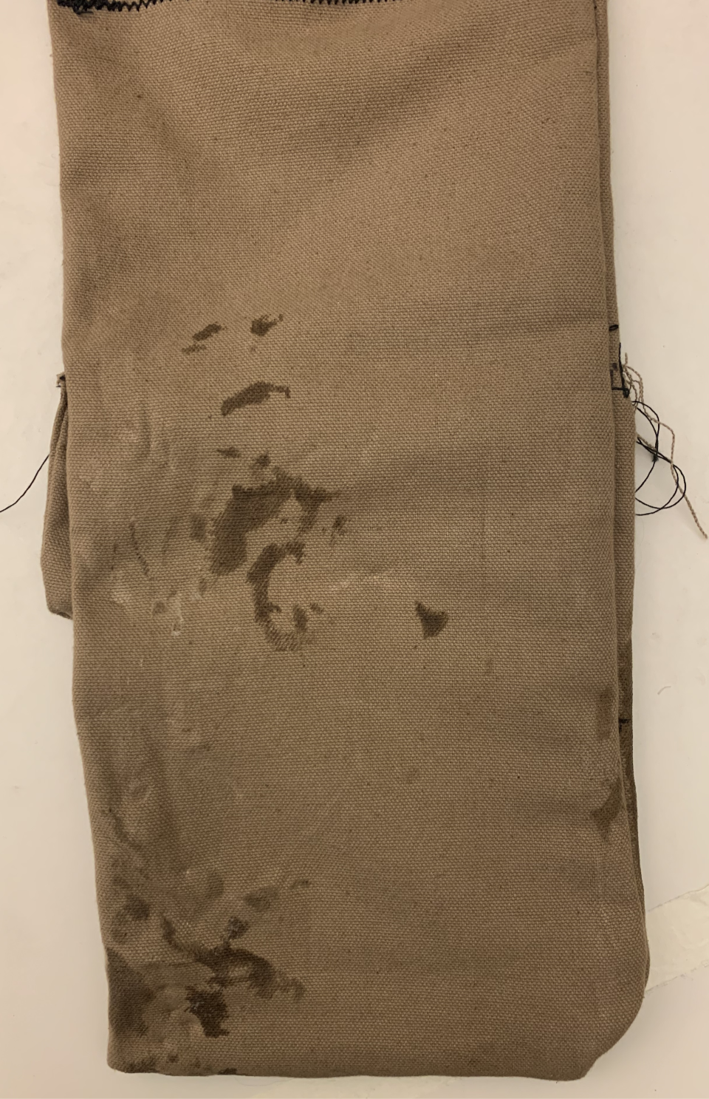

**Figure 4: Toy After Initial Play Session with No Monitoring – Back View.** This is the back perspective of Figure 3. This image likewise demonstrates biting along the top of the IMU pocket with other bites towards the very bottom edge of the toy as desired.

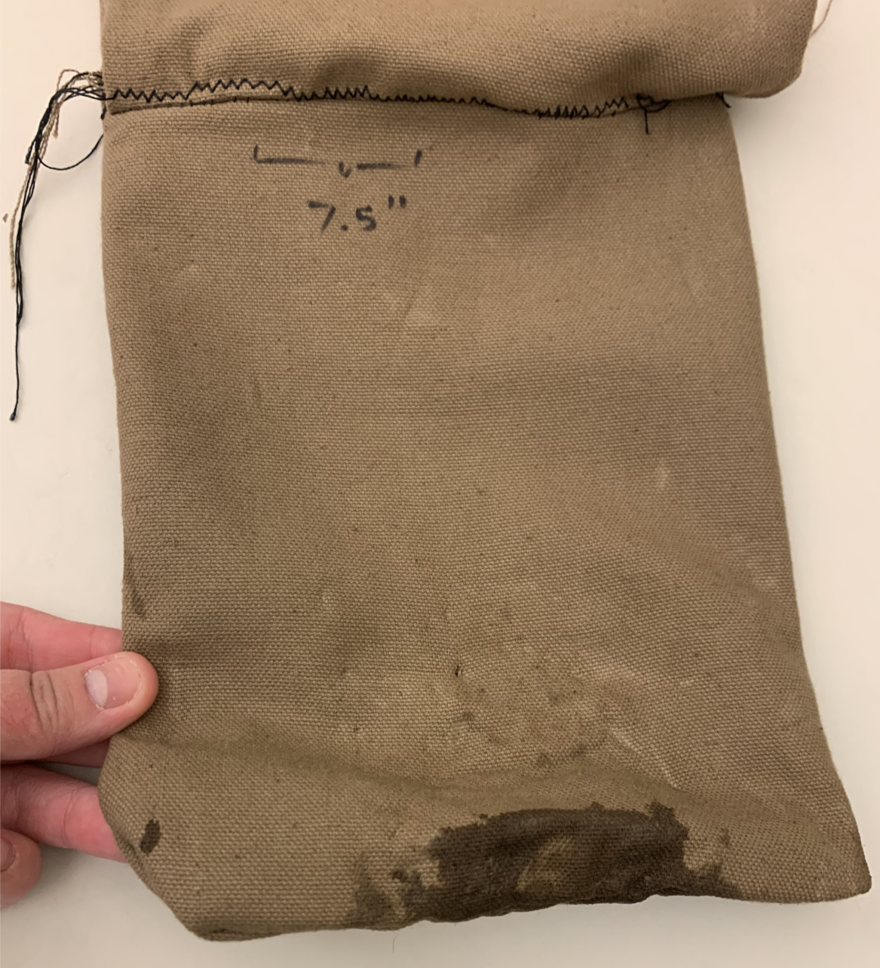

**Figure 5: Toy After Five Trials of Monitoring – Front View.** This image shows the final marks of the experiment. Of note are the various punctures throughout the bottom half of the toy edge both above and within the wet bite mark. Along the y-axis of the thumb includes one notable puncture that successfully pierced the first layer of canvas. The residual bites of Figures 3 and 4 are also evident on the pictured right edge. Moreover, the wet bite mark is representative of the difficulty the dog was having in issuing a strong bite grip as it is noticeable the dog aimed to use just her front teeth.

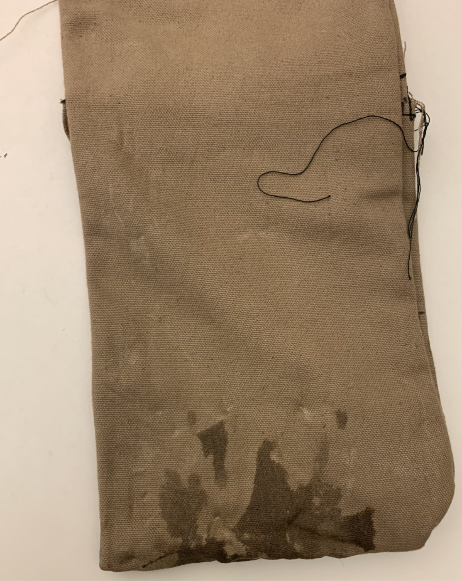

**Figure 6: Toy After Five Trials of Monitoring – Back View.** This image shows the back perspective of Figure 4. It demonstrates similar characteristics as the front side in some light punctures from teething towards the bottom edge of the toy and along the wet bite marks as well. The residual bites of Figures 3 and 4 are also evident on the pictured left edge.

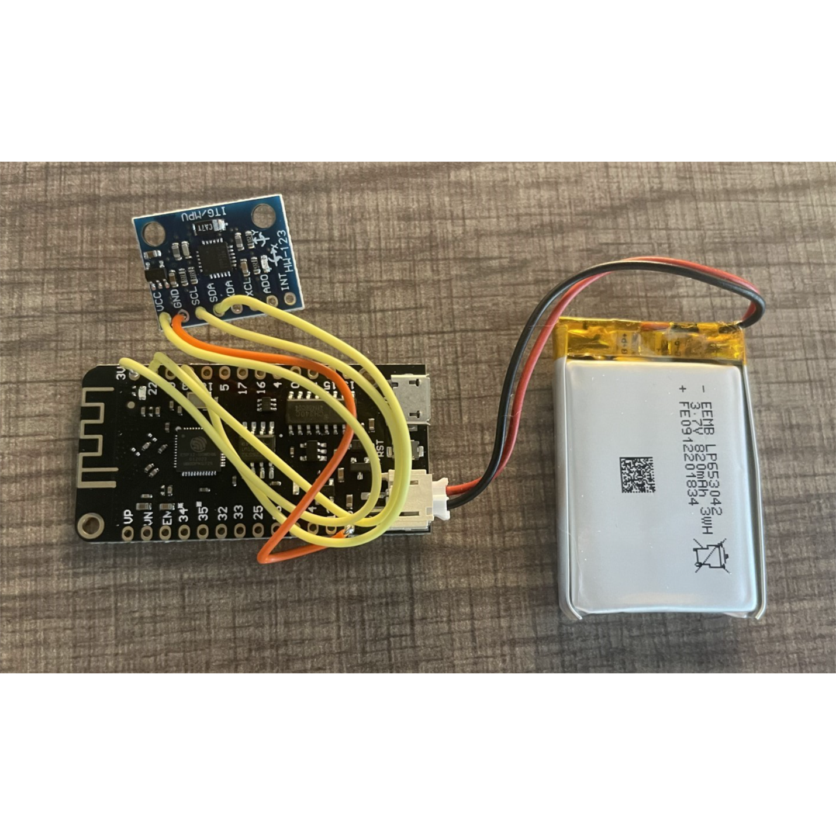  
**Figure 7: ESP32 and MPU6050 Configuration.** This image shows the connections of the battery, ESP32, and MPU6050.

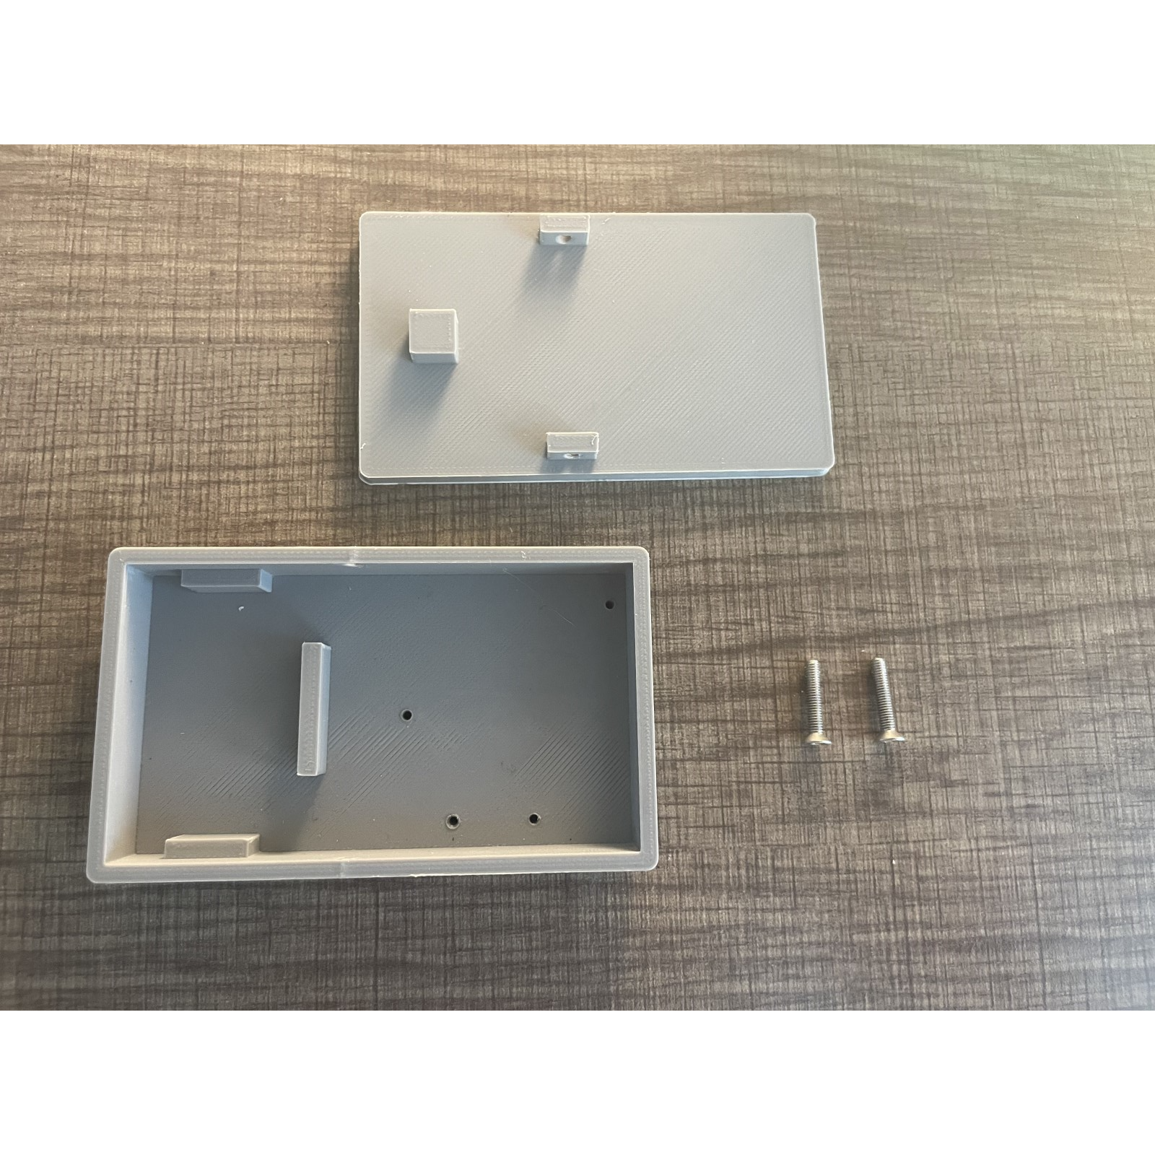  
**Figure 8: 3-D Printed Casing.**The 3-D printed casing was designed to host the battery independent of the IMU system for heat protection purposes. Additional divots in the design were created for screwing the entire system in place to avoid drift during use.

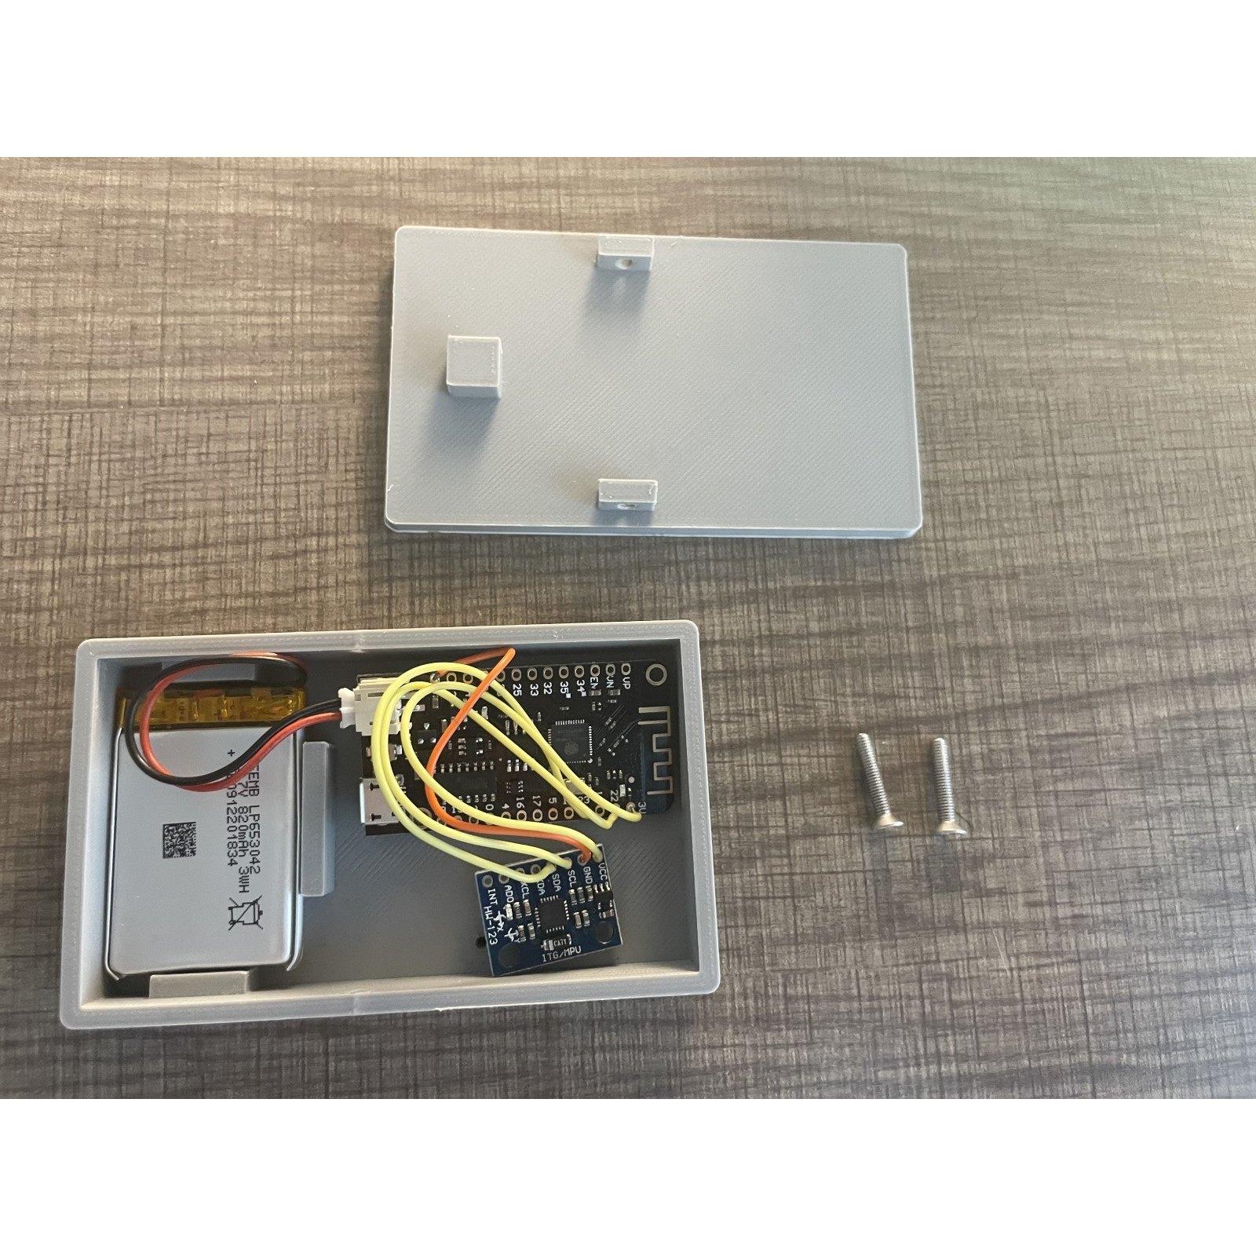

**Figure 9: System in 3-D Printed Casing.** Example of how the system would fit into the 3-D printed casing. Screws are removed for observability.

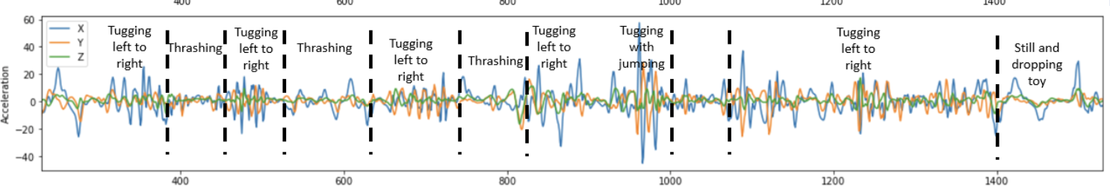

**Figure 10: Classification of Testing Data.** Classification of events in human testing